Silbido batch detector
Please read the ReadMeFirst file before attempting to use this software.
The Silbido contour detector can be used to find frequency modulated tonal calls in an automated manner. It generates a set of connected tonal calls that are represented as a graph, and then analyzes the graphs to extract individual whistles.
This document explains how to use the silbido algorithms on multiple files at a time. For details on the algorithms, please consult our articles:
M. A. Roch, T.S. Brandes, B. Patel, Y. Barkley, S. Baumann-Pickering, M.S. Soldevilla (2011) Automated extraction of odontocete whistle contours. J. Acous. Soc. Am., 130(4), 2212-2223.

P. Li, X. Liu, K. J. Palmer, E. Fleishman, D. Gillespie, E.-M. Nosal, Y. Shiu, H. Klinck, D. Cholewiak, T. Helble, and M. A. Roch, M. A. (2020). “Learning Deep Models from Synthetic Data for Extracting Dolphin Whistle Contours,” in Intl. Joint Conf. Neural Net. (Glasgow, Scotland, July 19-24), pp. 10. DOI: 10.1109/IJCNN48605.2020.9206992, arXiv preprint.

P. Conant. P. Li, X. Liu, H. Klinck, E. Fleishman, D. Gillespie, E.-M. Nosal, and M. A. Roch. “Silbido profundo: An open source package for the use of deep learning to detect odontocete whistles,” J. Acoustical Soc. Am., 152(6), pp. 3800-3808. DOI: 10.1121/10.0016631.

Introduction
The silbido batch detection interface is started by typing silbido_batch at the Matlab prompt. A window (Figure 1) will appear. The Audio Directory button can be used to specify where audio files are located. Currently, silbido only processes .wav files. All supported audio files that are contained in the selected directory or below it will appear in the Audio files box. If the Annotation Directory indicates where the detections produced by silbido will be stored. If it is not populated when the Audio Directory is selected, it will be set to the same directory, resulting in the annotations being placed in the same directory as the audio files. This can be set to a different directory if desired. Annotation files will preserve the relative directory structure of the audio files. For example, if the audio directory contains a file in a subdirectory, kona/2022-01-01T12:00:00.wav, detections will be in subdirectory kona of the annotation directory: 2022-01-01T12:00:00.ann.
The Configuration drop-down indicates which XML parameter set will be used for detections. To use silbido-profundo, the deep learning detector described in Conant et al. (2022) and Li et al. (2020), use the default setting of odontocete_deep.xml. See the detector documentation for more information on configuration files.
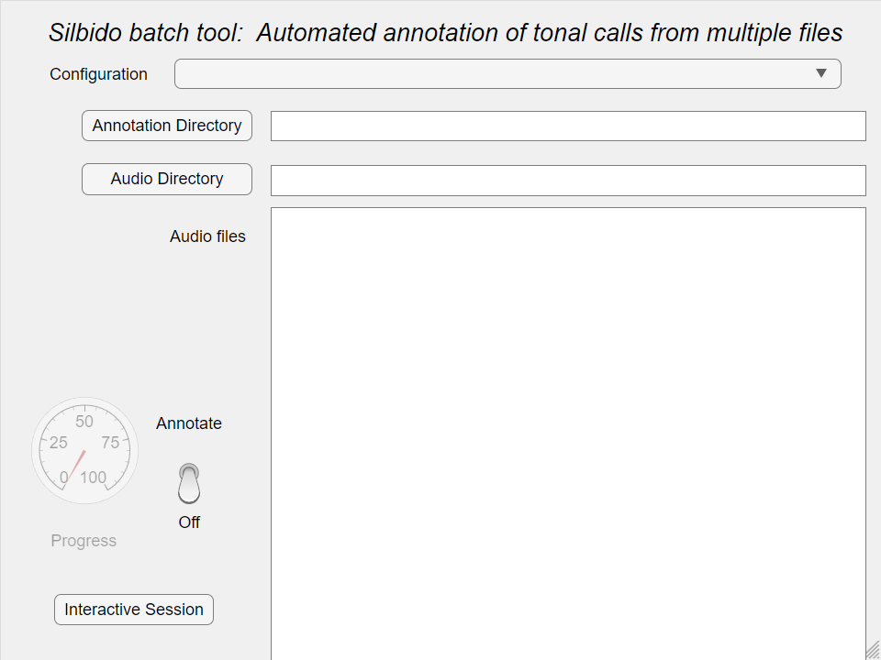
Figure 1- Silbido batch interface.
With the configuration, audio directory, and annotation directory specified, we are nearly ready to begin batch detection. Select the files to be selected from the Audio files list. Selection follows the paradigm for multiple-item selection (control-a for all, click and shift-click to select a range, etc.). Once files are selected, flip the switch to Annotate. The progress gauge will show the percentage of files processed, and items will be gradually deselected (Figure 2). Additional details are printed in the Matlab console.
Figure 2 – Silbido batch processor executing. When switch is moved to annotate, highlighted files are processed. As each file is processed, it becomes unhighlighted. The progress gauge indicates the percentage of initially selected files that have been processed.
The process can be aborted by flipping the switch to Off. The current file will finish processing before batch processing stops. In all cases, a summary of processed files, including any errors that occurred during the processing will be printed to the Matlab console.
The Interactive Session button on the interface can be depressed to launch an interactive session of silbido to review annotations or hand annotate. It invokes dtTonalAnnotate, see the Annotation document for details.

